

Cagney King: Eclectic Expressions
When: Fri., July 2, 5 p.m.-12 a.m. and Tuesdays-Fridays, 11 a.m.-5 p.m. Continues through Aug. 2
Phone: 317-955-2450
Price: Free.
www.artboxindy.com
ARTBOX’s Jason Myers describes Cagney King’s new works as “a journey of textures, poetry and loose palettes.” King presents a one-person show, “Eclectic Expressions,” at ARTBOX Gallery’s original location (217 W. 10th St.) with an opening reception Friday night, July 2 from 5 p.m. until midnight. Admission is free.

Artbox - Stutz II
  - 217 West Tenth St. ste.125
  - 317- 955 – 2450
  - www.artboxindy.com
Tags: Visual Arts+Museums, Editor's Pick
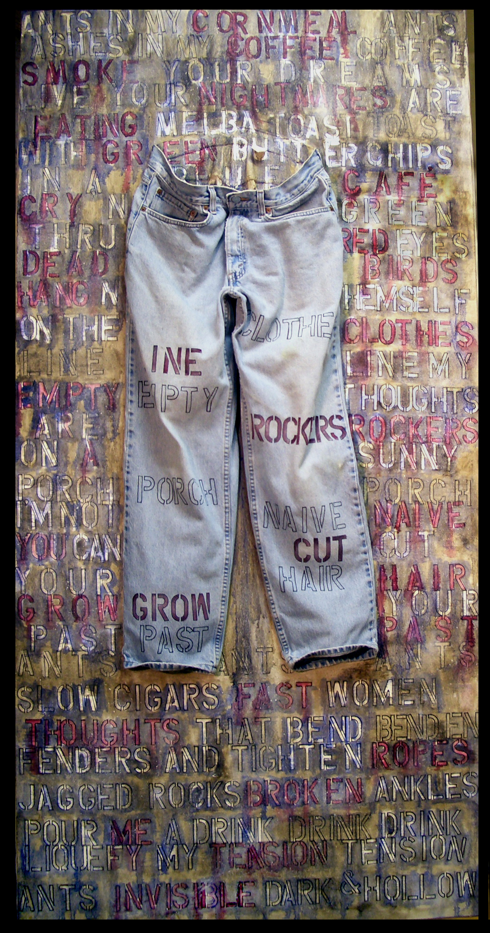
Poetry Pants – Cagney King

